The Design

The entire AutoUpdate Framework is written in Delphi XE2. Although initially BITS was going to be used to transfer the ﬁles since it offers the ability to throttle bandwidth, in the end, for simplicity sake, web services were employed instead.

The IUpdateService web service is exposed on port 8080 by default. The framework consists of four main components:

1) ClientUpdateService

2) Launcher

3) AutoUpdateServer

4) Deployment Manager

1) ClientUpdateService

The ClientUpdateService is a Windows NT Service that runs under the local system account and is responsible for downloading updates from the AutoUpdateServer to the client machine. All update processing occurs in subfolders under the application installation folder which is typically C:\Program Files\{ComapnyName}\{ProgramName}. The update folder structure consists of a subfolder called oddly enough, Updates which has 3 subfolders; Pending, Applied and Backup.

The ClientUpdateService polls the AutoUpdateServer at a predetermined interval (defaults to 20 minutes) which is speciﬁed in ClientUpdateService.ini. A default INI ﬁle is created the ﬁrst time the service is started, if one does not exist.

The INI ﬁle speciﬁes the URI of the AutoUpdateServer, in addition to the polling interval.

The ClientUpdateService sends the current application manifest to the AutoUpdateServer as part of the IUpdateService.GetUpdate request. If an update is available, the AutoUpdateServer provides the update components with a new manifest as part of the response. The ClientUpdateService saves the new manifest, and all ﬁles in the response into a new Updates\Pending subdirectory named for the UpdateVersion. The service then tells the AutoUpdateServer that it has successfully received the update by calling the IUpdateService.UpdateReceived method.

This method passes the ApplicationGUID, LocationGUID, and UpdateVersion to the server. Afterwards the service sleeps for the speciﬁed interval before checking for another update. The ClientUpdateService will never download the same update more than once, because the AutoUpdateServer knows it has already received the update.

2) Launcher

The Launcher is a Win32 client application that is responsible for actually applying any downloaded updates, and providing the user with appropriate feedback. The Launcher can be renamed so it will replace the current application if it has already been deployed, and act as an intermediate EXE ensuring all existing shortcuts still function. It creates a default INI ﬁle the ﬁrst time the program is started, if one does not exist. The INI ﬁle speciﬁes the program it is to launch if no update is present, or after the update(s) have been applied, the application install directory, where to look for updates, and the URI of the AutoUpdateServer.

Although the functionality has not been tested, the Launcher is capable of applying multiple updates at once. It should be veriﬁed that it applies multiple updates in the correct order before relying on this functionality. On startup, the Launcher reads all subdirectories that appear under Updates\Pending. It then applies the update by loading the manifest, backing up each ﬁle into a subdirectory it creates under Updates\Backup\X.X.X.X (where the Xs represent the UpdateVersion), and copying each ﬁle in the manifest into the application install directory. If the manifest indicates that the ﬁle is a patch ﬁle, the patch ﬁle will ﬁrst be used to create a ﬁle with the extension .NEW. The patched ﬁle will then be used to replace the version in the application install directory.

Errors are trapped along the way, and if any error occurs, the user is informed that the update failed and application may be unusable. No attempt is made to rollback the update. It is left for manual intervention in part to ensure tech support discovers why the update process failed, and because any automated rollback attempt is just as likely to fail. A complete copy of the previous version of all updated ﬁles can be found in Updates\Backup\X.X.X.X. Restoring users to a running version of application should be as simple as copying these ﬁles back into the installation folder, provided no database updates have occurred that would prevent the backup version from running.

If an update is successfully applied, the Launcher informs the AutoUpdateServer by way of the IUpdateService.UpdateApplied method. This method passes the ApplicationGUID, StudioGUID, UpdateVersion, UpdateResult, and UpdateLog to the server which records the information for viewing in the Deployment Manager.

3) AutoUpdateServer

The AutoUpdateServer is a Win32 NT Service running under the local system account, that sends an update to the ClientUpdateService when it checks using the IUpdateSever.GetUpdate method. The service creates a default INI ﬁle the ﬁrst time it is started, if one does not exist. The INI ﬁle only contains the DataSource for the SQL Server database where the server looks at the Deployment and LocationDeployment tables to track updates. The service connects to the database using the normal Studio account. A separate account could be used as long as it has access to query the Studio table and both query and update the Deployment and LocationDeployment tables.

This service can be compiled as a Win64 NT Service, but currently throws an I/O related exception in the utility methods used for binary ﬁle streaming. All updates are static, meaning the contents of the update are determined when the update is created and not on a per request basis from the client. In order to reduce the bandwidth and server utilization, binary patch ﬁles are supported using Microsoft's delta compression technology.

4) Deployment Manager
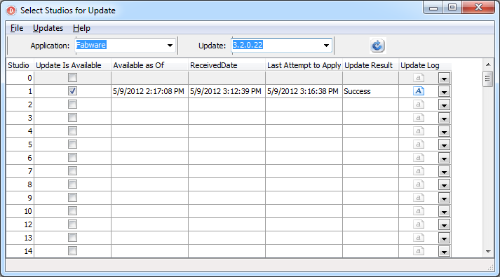
The Deployment Manager is a Win32 application providing a view of the current version of application in each studio. The Deployment Manager creates a default INI ﬁle the ﬁrst time it is started, if one does not exist. The INI ﬁle contains the DataSource for the SQL Server database where the Deployment Manager manipulates the Deployment and LocationDeployment tables to track updates. It also contains the Path to the root UpdateServer folder where it creates the Updates subfolders and copies the ﬁles when a new deployment is created. The INI ﬁle also contains a default source folder setting for new application components to be deployed.

An update involves the creation of a directory on the server containing all executable components and support ﬁles necessary in addition to a new manifest ﬁle. The Deployment Manager automates the creation and management of the directory structures used by the Update Server. In the event of a problem with an update, pending updates can be cancelled by unselecting recipient locations.
The most recent Update is displayed on startup in the main form. The status of previous updates can be viewed by changing the current update version in the combo box. Although the application could support more than one application, the only one available at this time is application.

To create an Update, simple chose Updates - Create. The New Deployment dialog will appear.
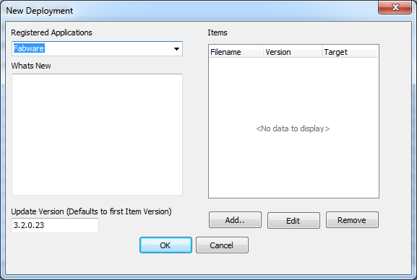
Simply populate the Whats New section, and add any items that have changed to the deployment. The Update Version automatically defaults to the next higher version not in use.
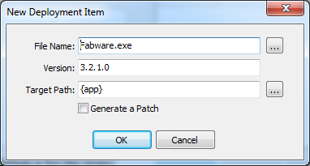
Adding a new deployment item invokes the New Deployment Item dialog.
Select the application component by clicking on the elipses button next to the FileName and choosing the EXE or DLL.
The verison information will automatically be read from the component and the target path will be set to the variable
{app} which is the installation folder.
If you click on Generate a Patch an open dialog will be presented where you need to select the previous version of the
deployment item that is being upgraded to the previously selected item. The Deployment Manager verifies that the
version of the selected file is prior to the current one to be deployed, and generated a patch.

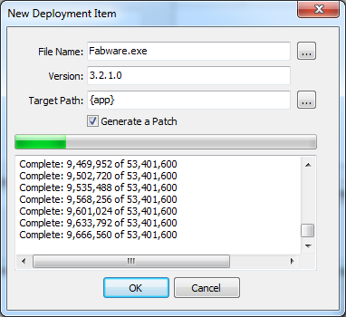
Once all items have been added to a deployment, click Ok and you’re returned to the main form displaying the update that was just created.
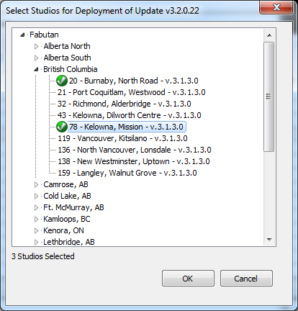
Choose the Update - Manage menu options to invoke the Select Locations for Deployment dialog:
Locations are presented in a treeview hierarchy starting with the Regions, Provinces, and Cities. The current version in use
at each location is displayed. At each level, the user can select all child nodes making it possible to apply an update to a
specific region, province, city, or location. Right Click on a tree node to select or unselect it, or it’s children.
The Manifest
The manifest is an XML or structured text file that contains a version # which is usually the same version of the primary
EXE, but it can also be the designated version of the software suite. The Manifest contains:
UpdateVersion
WhatsNew
1..N of the following where N is the number of deployment items or application components:
FileName
Version
TargetPath
IsAPatch
The Deployment Manager automatically generates the manifest for a deployment, and the ClientUpdateService
generates an initial manifest if one doesn’t exist, but naturally the information contained within will not be accurate.

